Dry Bath Incubator——DH300,DC10
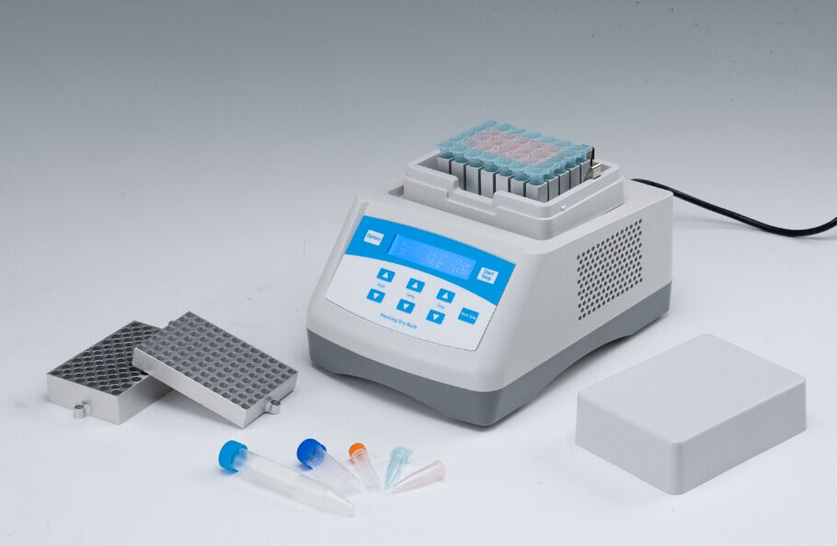
Description:
DH300/DC10 is microprocessor controlled Dry Bath Incubator. Instead of traditional water bath device, the heat-conducting medium is high purity alumium. The exact desired temperature is easily set using the arrow keys on the sloped control panel while values are shown on the large digital display. No checking of a thermometer and readjusting temperature is necessary. The user calibration feature allows for easy calibration to in house standards when required.
This product can be widely used in preservation and reaction of samples, DNA amplification, electrophoresis denaturation and serum solidification, etc.
Features:
- LCD display.
- Automatic fault detection and buzzer alarm function
- Temperature calibration function.
- Easy replacement and cleaning of block.
- Built-in over temperature protection.
- Multiple safety protection. Safe and reliable with CE standard.
- Customized blocks are accepted.
- 12-month warranty.

Parameters:
Model | DH300 | DC10
Temp setting range | 0℃~100℃ | -10℃~100℃
Temp range | RT+5℃~100℃ | RT.-30℃~100℃
Time range | 1min ~ 99h59min/∞ | 1min ~ 99h59min/∞
Temp accuracy | ≤±0.3℃* | ≤±0.3℃*
Display accuracy | 0.1℃ | 0.1℃
Temp uniformity | ≤±0.3℃* | ≤±0.3℃*
Heating time | ≤12min(from 25℃ to 100℃)* | ≤12min(from 25℃ to 100℃)*
Cooling time |  | ≤10min(from 100℃ to 25℃)*
Cooling time |  | ≤25min(from RT. to RT.-30℃)*
AUTO-4℃ |  | Yes*
Multi points running | Yes(Max 5points) | Yes(Max 5points)
Multi points running circularly | Yes(Max 99times) | Yes(Max 99times)
Auto heating | Yes | Yes
Auto running | Yes | Yes
Auto resume to run | Yes | Yes
Power | 150W | 150W
Voltage | AC220V or AC110V / 50-60HZ | AC100~240V/50-60Hz
Fuse | 250V 3A Ф5×20 | 250V 3A Ф5×20
Dimension(mm) | 260x195x150 | 260x195x150
Weight | 2.5kg | 4.5kg

Optional Blocks:
Type Description
MD30 96×0.2ml
MD31 54×0.5ml
MD32 35×1.5ml
MD33 35×2.0ml
MD34 15×0.5ml+20×1.5ml
MD35 96×0.2ml（elisa plate）
MD36 24×5ml
MD37 15×10ml
MD38 12×15ml
MD39 6×50ml(round-shape bottom)
MD39-S 6×50ml(cone-shape bottom)

